Sri Lanka Institute of Information Technology


IT1040 - Fundamentals of Computing
Year 1, Semester 1- 2024

HOME AUTOMATION SYSTEM

Progress Report
Group 10-18

IT Number | Name
IT24101461 | Hannadige A.K.L.F
IT24102560 | Nirmana A.A.H
IT24101368 | Sandakan K.D.S
IT24101272 | Sewmini A.D.B
IT24101661 | Aberathna B.D.S
IT24103582 | Tharindu K.T.D.S

- Introduction
Home automation system is a very big aspect in newest technology that allows you to remotely manage and control various parts of your home .They can be lights, temperature ,security and entertainment system.
In our project we decided to create auto lightning system, auto door system, auto cooling system by using fans.we are going to create this by using ardinou uno/ESP 32.

- System Architecture
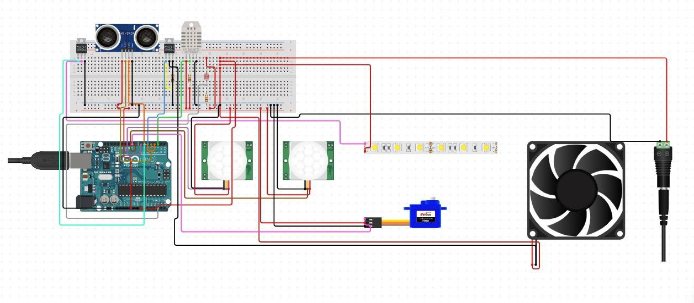

AUTO DOOR SYSTEM | AUTO LIGHTNING SYSTEM | AUTO COOLING SYSTEM
Arduino board/ESP 32  Server motors  Cardboard doors(prototype)  Jumping wires | Arduino board  PIR Motion sensors  Jumping wires  LED | Arduino board  Jumping wires  motor

- Work Breakdown Structure

- Proof of Work

